1. Modify the Oozie configuration for the Oozie interaction with Kerberised HBase cluster:
2. Go to Ambari UI and stop the oozie services.
3. Click on the Oozie services and modify the below configuration.

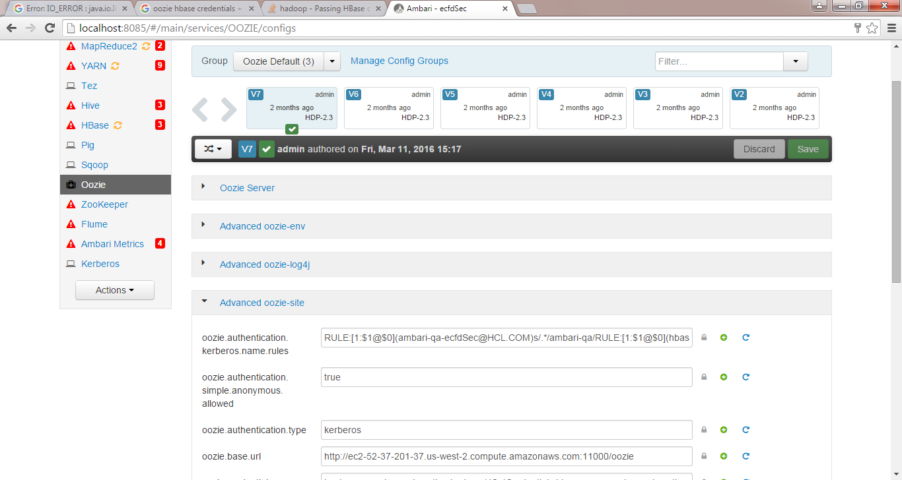

1. Modify the “oozie.credentials.credentialclasses” with “hcat=org.apache.oozie.action.hadoop.HCatCredentials,hbase=org.apache.oozie.action.hadoop.HbaseCredentials,hive2=org.apache.oozie.action.hadoop.Hive2Credentials”

This parameter will enable the Oozie to create the HBase credentials which can be utilized the Oozie workflow.

1. copy the below jars into the following folder:

**Please note that this folder is available only in Oozie-server Machine.**

1. sudo cp /usr/hdp/2.5.0.2-3/hbase/lib/hbase-common-1.1.2.2.5.0.2-3.jar /usr/hdp/current/oozie-server/oozie-server/webapps/oozie/WEB-INF/lib
2. sudo cp /usr/hdp/2.5.0.2-3/hbase/lib/hbase-client-1.1.2.2.5.0.2-3.jar /usr/hdp/current/oozie-server/oozie-server/webapps/oozie/WEB-INF/lib
3. sudo cp /usr/hdp/2.5.0.2-3/hbase/lib/hbase-protocol-1.1.2.2.5.0.2-3.jar /usr/hdp/current/oozie-server/oozie-server/webapps/oozie/WEB-INF/lib
4. sudo cp /usr/hdp/2.5.0.2-3/hbase/lib/hbase-server-1.1.2.2.5.0.2-3.jar /usr/hdp/current/oozie-server/oozie-server/webapps/oozie/WEB-INF/lib
5. Login to "hbase shell" and execute the below command:

grant 'oozie', 'RWCX'

This will allow oozie to access the HBase tables.

1. Restart the Oozie from Ambari UI.
2. Incase if you face any issues please revert back the changes.